Wireshark
Installation on Linux:
Linux is the best environment for packet analysis and other pen test tools it also have tcpdump already installed on it.
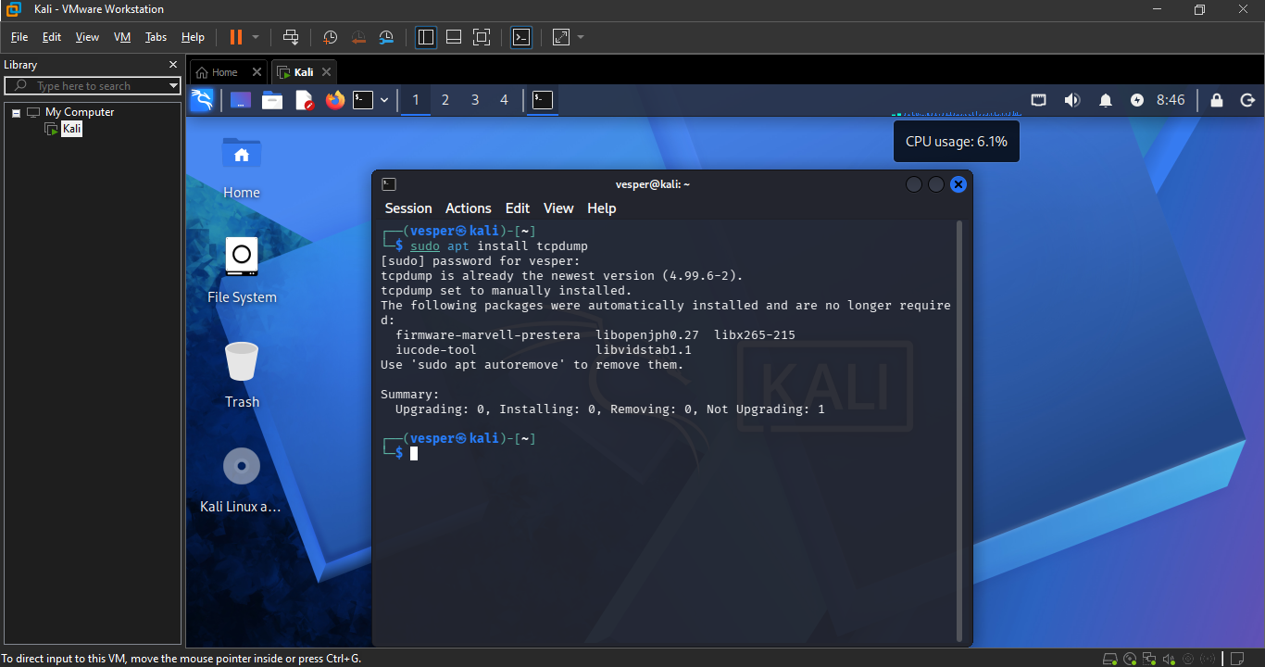
It also have iptables netstat and ipconfig installed on it. Make sure to check that net-tools are installed or not they came already installed in the kali Linux.
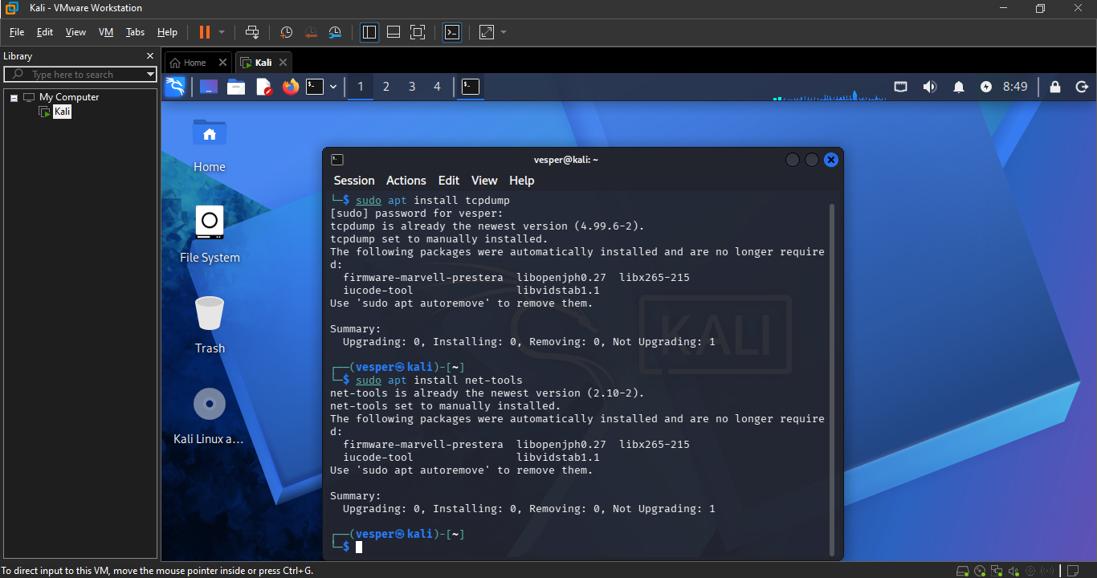
We are going to install the Wireshark from command line which is an easy way. Always make sures to start by updating your system package list and then installs the software to make sure you are installing the latest software versions this is important because it in sures you are not installing the outdated software and it also insure prevent dependencies issue during Installation.
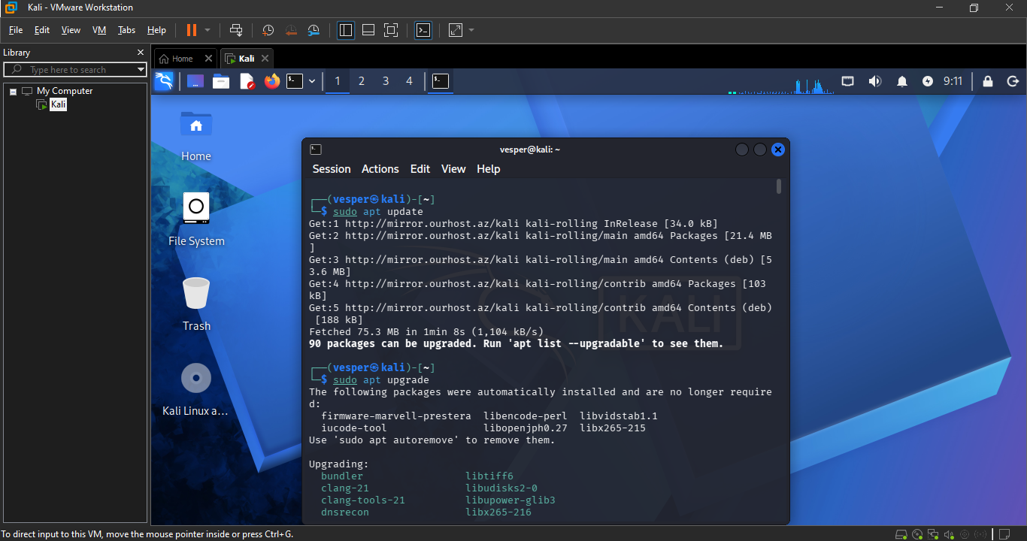
Wireshark is already installed
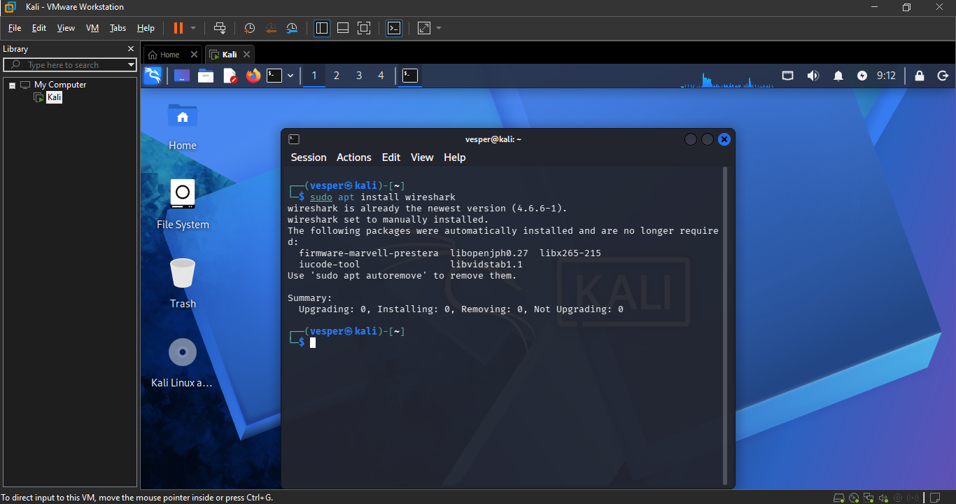
Now add the user to the Wireshrak group this step will ensure you can capture packets without administrative privileges.
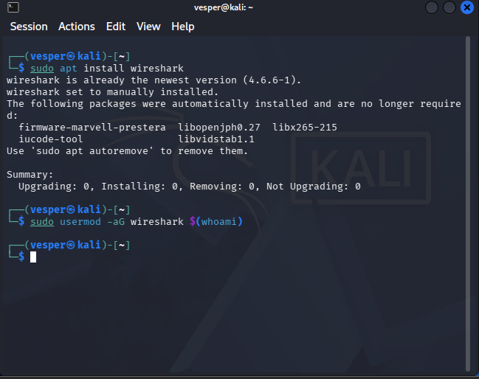
This step is important as it enhance security by reducing the need to run Wireshark as root. It’s a good practice running as a regular user will minimize the potential impact of security vulnerabilities.
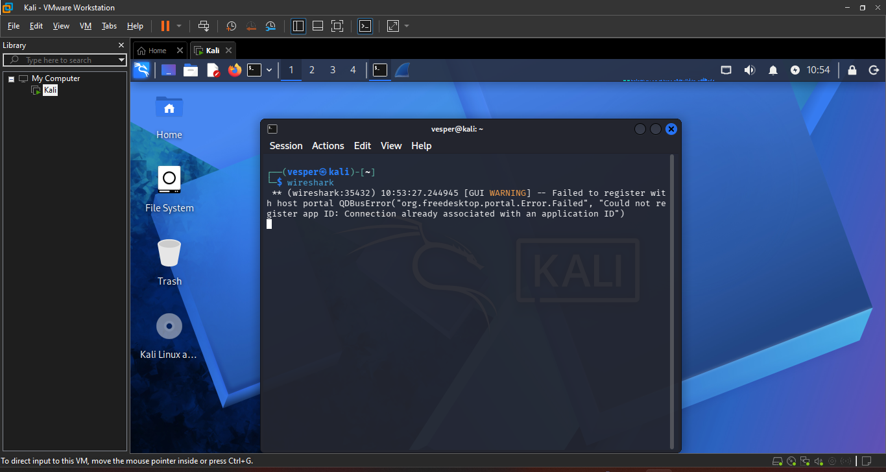
Here we are running Wireshark
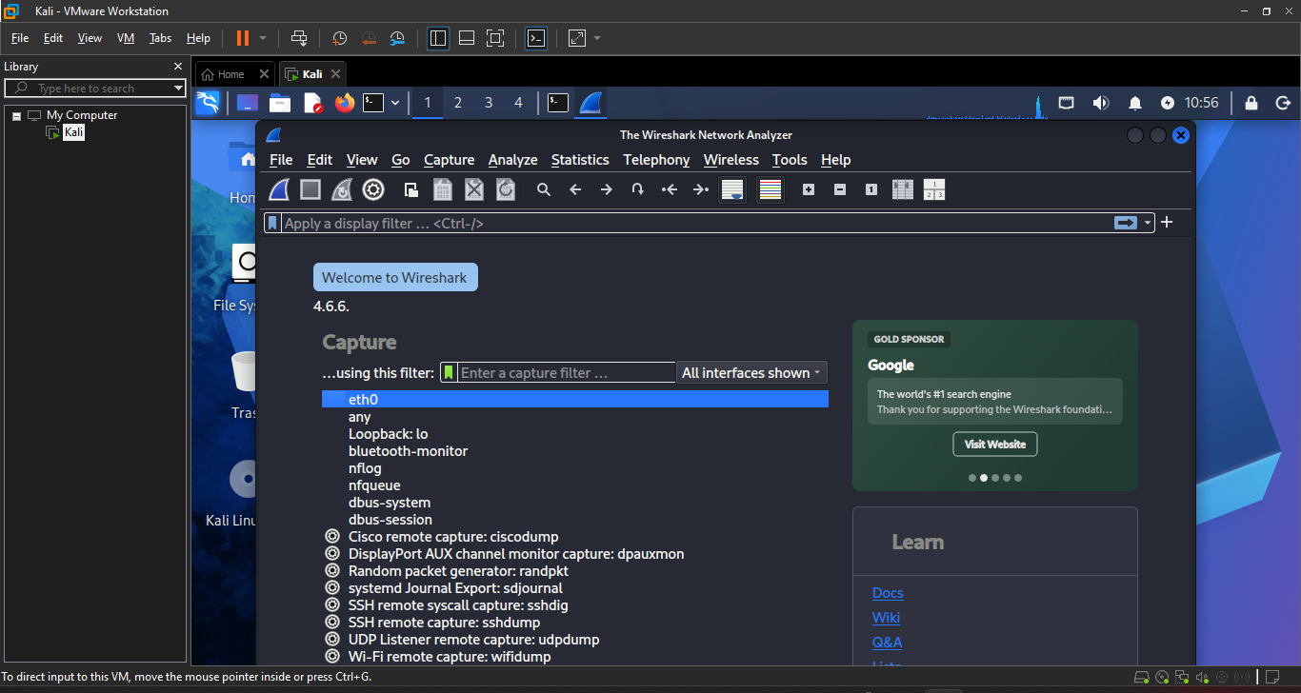
Now we are going to install some additional tools like tcpdump , tshark , nmap
Tcpdump is the common line packet analyzer, the tshark is terminal based version of Wireshark and nmap is the powerful network scanning tools.
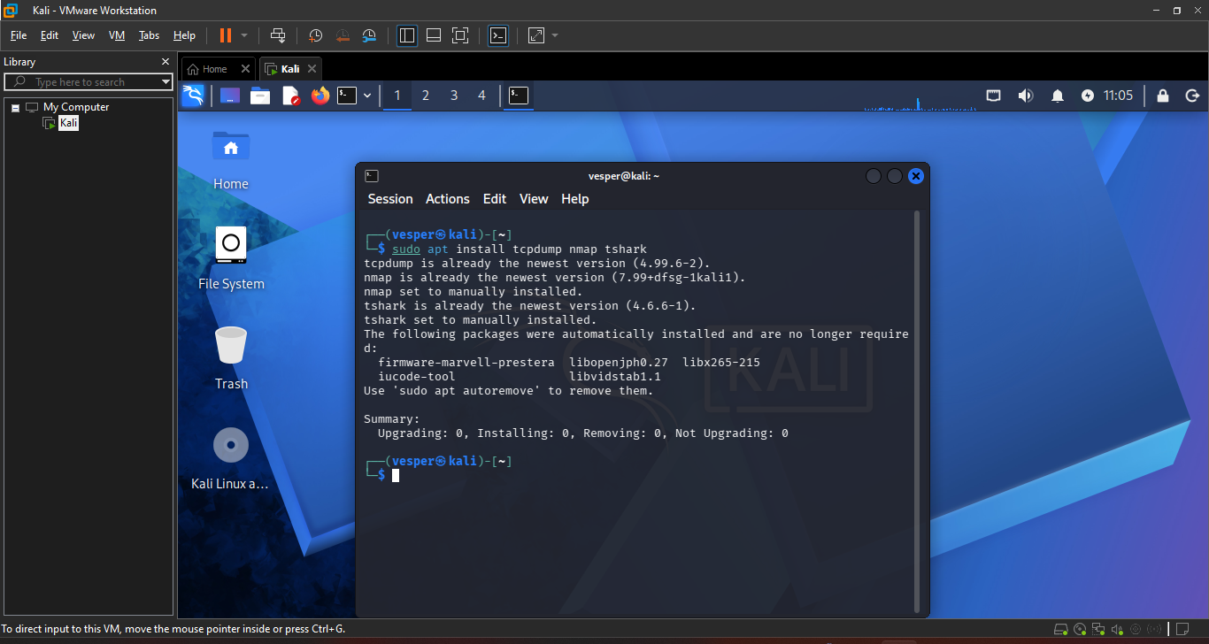
Now we are ready to run Wireshark on Linux it gives us unparallel control over packet analysis.

